

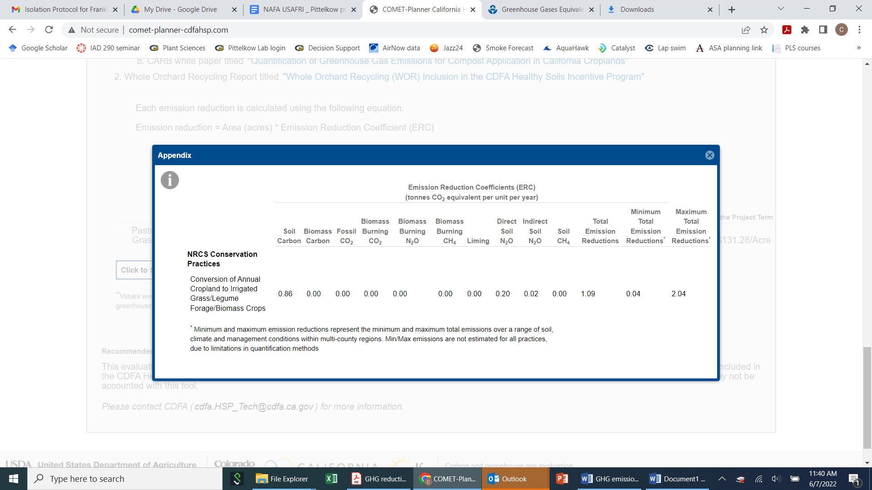

Soil carbon sequestration estimate of 0.860 Metric tons CO2 eq/ac/yr

“Emission reduction coefficients were largely derived using a sample-based approach and model runs in COMET-Farm, which utilizes USDA entity-scale greenhouse gas inventory methods. Coefficients were generalized by multi-county regions defined by USDA Major Land Resource Areas. Emissions estimates represent field emissions only, including those associated with soils and woody biomass as appropriate, and do not include off-site emissions, such as those from transportation, manufacturing, processing, etc.”

Conversion to carbon only and hectares instead of acres:

0.86 Mg CO2e/ac x (2.47 ac/ha) = **2.12 Mg CO2 eq/ha/yr**

0.86 Mg CO2e/ac x (12 units C/44 units CO2e) x (2.47 ac/ha) = **0.579 Mg C/ha/yr**

This is about 2.5 times the soil carbon benefit of cover crops. Positive changes in SOC reflect the net capture of atmospheric CO2 in croplands, with different practices such as perennial crops or changes in tillage and nutrient management capable of mitigating GHG emissions by more than 0.5 Mg CO2 eq ha-1 yr-1 (Paustian et al., 2016). This widely cited review estimated that cover crops enhance SOC by 0.23 Mg C ha−1 yr−1, which is 844 kg CO2 eq/ha/yr.

The original meta-analysis determining this value was Poeplau and Don (2015) - Carbon sequestration in agricultural soils via cultivation of cover crops—a meta-analysis. *Agric. Ecosyst. Environ.* **200,** 33–41.

For COMET farm in Yolo County, the COMET planner calculator shows an estimate of 0.15 Mg CO2e/ac impact of non-legume cover crops in irrigated cropland, which is 5.7x smaller than the benefit of perennial forages. For legume species, this is 0.37 Mg CO2e/ac, or 43% of perennial forages.

This is on the highest possible range for no-till in literature and double that reported by COMET farm for California. For eample, [**West & Post (2002)**](https://onlinelibrary.wiley.com/doi/full/10.1111/j.1365-2486.2008.01743.x#b50) estimated a change from conventional tillage (CT) to NT could sequester around 140–570 kg C ha/yr−1. When converted to CO2eq, 0.3 Mg C/ha/yr is 1.1 Mg CO2 eq/ha/yr. This relates to a change in N rate of 108 kg N/ha/yr. For COMET farm in Yolo County, the calculator shows an estimate of 0.42 Mg CO2e/ac for irrigated cropland, or more than 2x smaller than benefit of perennial forages.

This represents a reduction of around 200 kg N fertilizer/ha, assuming that direct plus indirect emissions from fertilizer production, transport, field emissions, and indirect emissions total around 10.15 kg CO2 eq/kg N fertilizer.

Note in COMET farm there are four different options, ranging from normal to high seeding rate and with or without lime or fertilizer. These would generate different economic payments, due to different costs for grower, but all produce the same net GHG benefits:

